Student Name :- Sonali M. Phate

Project Name:- TO DO LIST

Description:-

This HTML code sets up a basic To-Do List web application. It incorporates Bootstrap for styling, jQuery for DOM manipulation, and Font Awesome for icons. The layout includes a header with a title and an input field for adding tasks, displayed within a card element. JavaScript functionality for task management is likely contained in an external script file named "script.js".

A to-do-list project is a collection of tasks that outlines the work a project manager or team plans to complete during a project. It helps project managers understand the various task of project so they can assign work to team members and fullfill their own duties. To-do-list project can also be an application that keeps track of tasks thar need to be done.

Benefits/Advantages of To Do List:-

#### Brings structure to the day.

#### Less to hold in the head.

#### Better Time Management.

#### Breaks goals into action points.

#### Prioritize

#### Screenshots:-

#### Main Page

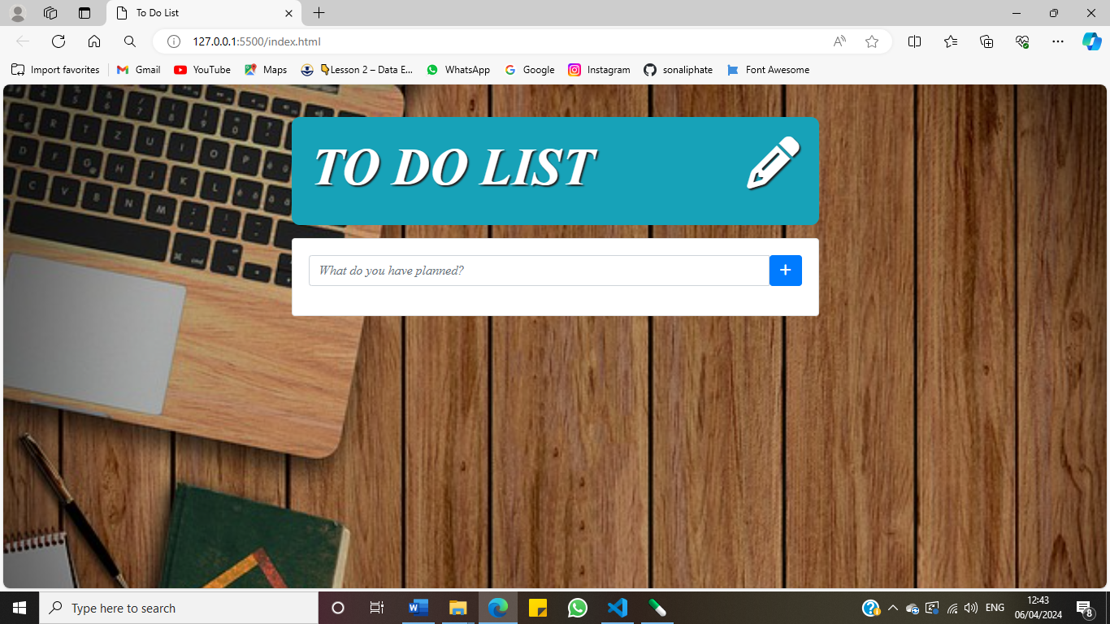

1. Add Tasks

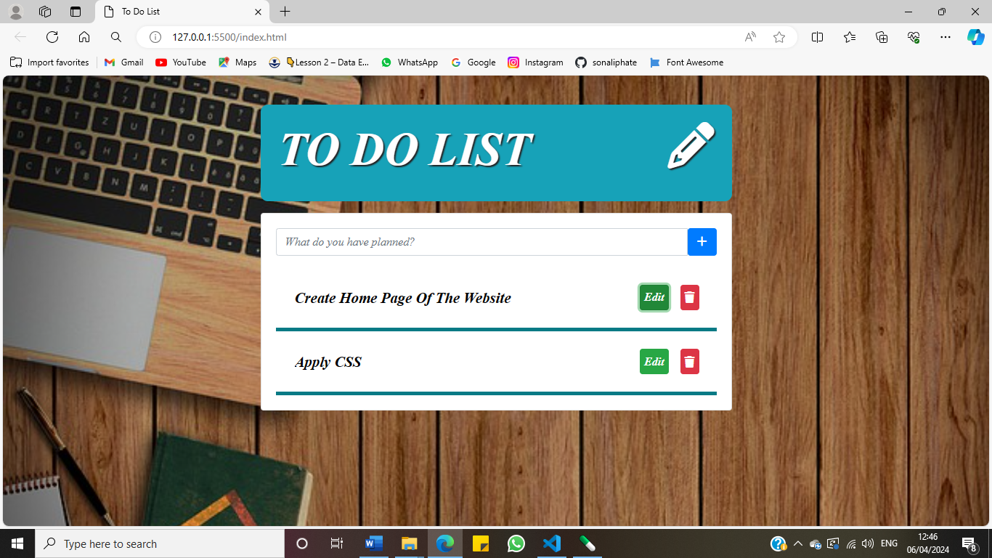

1. Edit Task

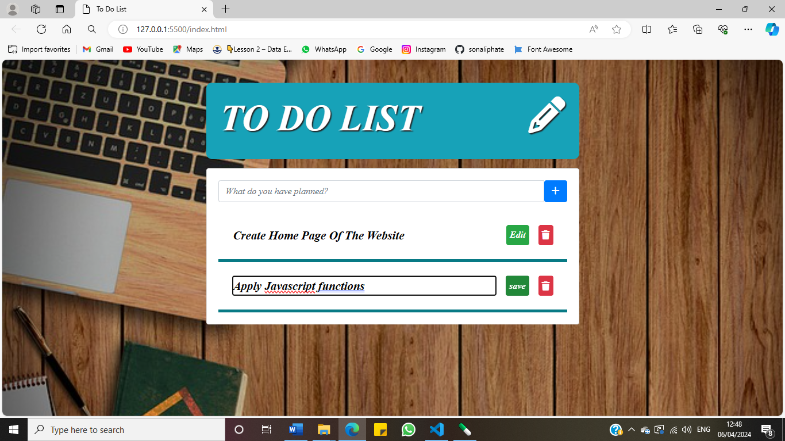

1. 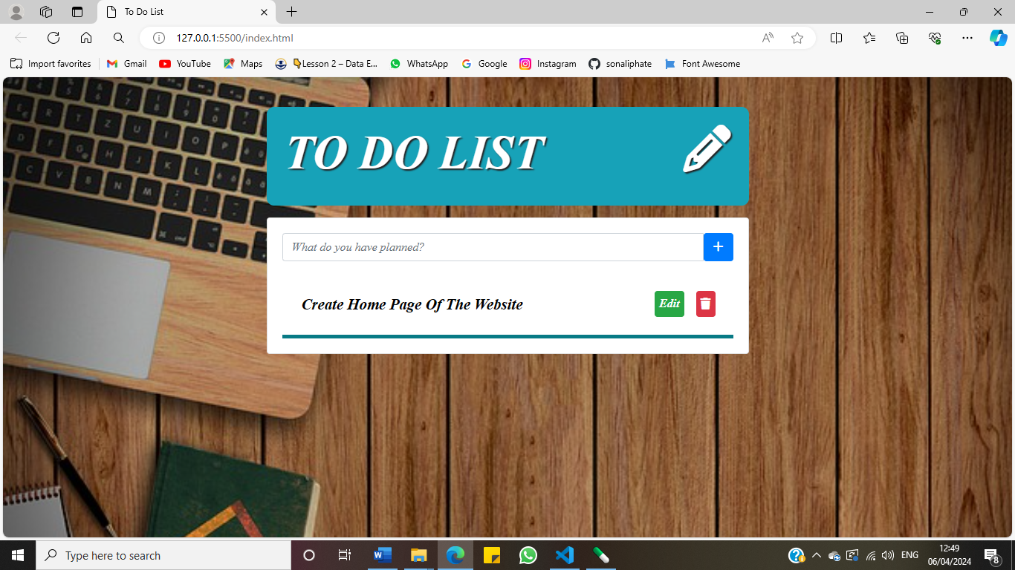Delete Task